**Prediction**

5-fluoro compound 1

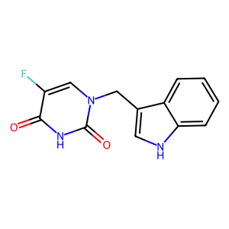

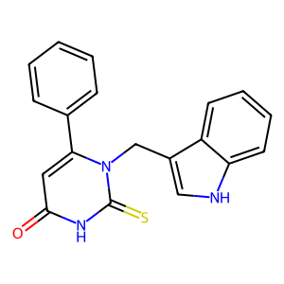6-fenylo compound 2

5-propylo compound 3

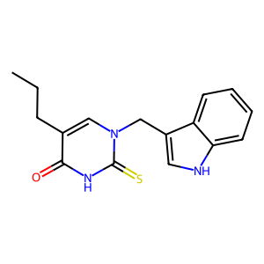

6-propylo compound 4

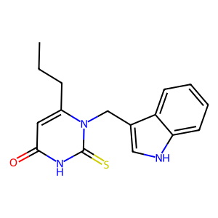

**Irman La Ode Jaya, Lucyna Mrówczyńska**

**Zakład Biologii Komórki UAM Wydział Biologii**

**Biological activity *in vitro* – results and main conclusion**

1. **Hemolytic activity (human red blood cells, RBC)**

- after the standard incubation (1 hour at 37°C) at the concentration of 0.05 and 0.1 mg/mL, compounds 1-4 are cytotoxic (hemolysis degree >5%, Table S1); hemolytic activity of all compounds is a structure- and a dose-dependent

- after the standard incubation (1 hour at 37°C) at concentration of 0.01 mg/mL hemolytic activity of compounds (Table S1) is higher than obtained for negative control (PBS buffer) equal to **3.14±0.14** (Fig. S5); however, any value lower than 5% allows any compounds defined as hemocompatible for potential biomedical applications.

**Table S1**

Hemolytic activity (%) of compounds 1-4 at the concentration range from 0.1 mg/mL to 0.01 mg/mL presented as mean ± SD (n=11-17). after standard incubation (1 hour, 37°C) Hemolysis for negative control (PBS buffer) was equal to **3.14 ± 0.14**

|  |  |  |  |
| --- | --- | --- | --- |
| **Compound** | **0.1 mg/mL** | **0.05 mg/mL** | **0.01 mg/mL** |
| 1 | 9.57 ± 3.99 | 5.60 ± 2.09 | 4.13 ± 1.13 |
| 2 | 16.71 ± 6.65 | 10.97 ± 3.98 | 4.89 ± 1.24 |
| 3 | 17.36 ± 6.60 | 8.44 ± 2.47 | 4.84 ± 0.84 |
| 4 | 8.79 ± 2.21 | 4.92 ± 0.45 | 4.34 ± 0.54 |

**Fig**. **S5.** Hemolytic activity (%) of compounds 1-4 at different concentrations (mg/mL) after 1 hour incubation at 37°C. Hemolysis calculated for a negative control (RBC in PBS buffer, 0 mg/mL) is also presented. The red line is plotted for a hemolysis threshold of 5%. Hemolysis activity higher than 5% indicates a membrane-perturbing activity of the compound and its cytotoxic properties. Values are presented as mean ± SD (n=11-17)

**2. Cytoprotective activity under oxidative stress conditions**

- cytoprotective activity of compounds was evaluated at their sublytic concentration equal to 0.01 mg/mL.

- cytoprotecive activity of compounds 1-4 was evaluated in two different levels:

1. cell membrane (oxidative hemolysis inhibition)
2. hemoglobin (protection against oxidation into methemoglobin Fe3+).

*2.1. Cell membrane level*

All compounds inhibit an oxidative hemolysis induced by free radical generated from the standard oxidative hydrofilc agent 2,2'-azobis(2-methylpropionamidine) dihydrochloride (AAPH) in the structure-depended manner (Fig. S6). The cytoprotective activity of compounds 3 and 4 is statistically the same (*p*>0.05) as obtained for the Trolox (standard antioxidant). The chemical structure of 3 and 4 is similar (prediction – *the role of the propyl groups in the specific membrane incorporating*).

**Fig. S6.** Cytoprotective properties of compounds 1-4 used at the concentration 0.01 mg/mL 60 mM against 2,2’-azobis(2-methylpropionamidine) dihydrochloride (AAPH)-induced oxidative hemolysis (means ± SD, n=12-13). Values denoted with identical letters do not differ significantly

*2.2. Hemoglobin level*

Hemoglobin (Hb) is the main intracellular protein of human RBC with the function of oxygen transport. Hb (Fe2+) undergoes autooxidation to methemoglobin (MetHb) with hem iron oxidized (Fe3+). MetHb is inactive protein as an oxygen transporter.

To investigate the hemoprotective role of compounds 1-4 (0.01 mg/mL) against Hb oxidation to MetHb, the spectral scans of Hb (450–700 nm) in supernatants were performed. Oxyhemoglobin is characterized by two peaks at 540 and 570 nm, whereas MetHb gives is characterize by a peak at 630 nm.

As shown in Fig. S6, in the supernatants obtained from AAPH sample (red line), the oxy-Hb peak decreases and a specific MetHb peak appears (absorption values 0.056 – Fig. S7 and its table). In the presence of compounds 1-4, the MethHb peak decreased (from 0.038 to 0.029, Fig. S7 and its table) and compound 3 protects Hb better than the standard antioxidant Trolox (0.29 and 0.031, respectively).

**Figure S7.** Spectral scans (450–700 nm) of hemoglobin (Hb) in supernatants after 4 h of incubation of RBC in 60 mM AAPH (red line), compounds 1-4 in 60 mM AAPH (different colors) and standard antioxidant Trolox (blue line) used at 0.01 mg/mL. Absorbance values (Ab) measured at 540, 578 (oxy-Hb peaks), and 630 nm (MetHb peak) are presented for every scan. The representative data for a series of experiments are presented

**Final conclusion**

- hemolytic activity of compounds 1-4 is a structure- and a dose-dependent at the concentration range from 0.01 to 0.1 mg/mL

- at the concentration of 0.01 mg/mL all compounds are hemocompatible (jhemolysis degree<5%) and they can be used for potential biomedical applications

- all compounds 1-4 inhibit free radicals-induced hemolysis and protect hemoglobin against oxidation to methemoglobin in the structure-dependent manner

- compound 3 shows the best cytoprotective activity as (a) a membrane protective agent (inhibition of oxidative hemolysis – Fig. S5) and (b) as a hemoglobin protective agent (inhibition of Hb oxidation – Fig. S6).

**Materials and methods**

*Human erythrocyte preparation*

All methods were carried out following relevant guidelines and regulations, and the Bioethics Committee approved all experimental protocols for Scientific Research at the Medical University of Poznań (agreement no. ZP/2867/D/21). Human RBC concentrates were purchased from Blood Bank in Poznań without any contact with blood donors.

The erythrocytes were washed three times (3000 rpm, 10 min, +4°C) in 7.4 pH phosphate buffered saline (PBS: 137 mM NaCl, 2.7 mM KCl, 10 mM Na2HPO4, 1.76 mM KH2PO4) supplemented with 10 mM glucose. After washing, RBC were suspended in the PBS buffer at 1.65x109 cells/mL, stored at +4°C, and used within 5 h.

*Hemolytic assay*

The cytotoxic activity of the compounds tested was determined by a standard hemolytic assay according to Mrówczyńska and Hägerstrand [1]. Briefly, RBC (1.65x108 cells/mL, ~1.5% hematocrit) were incubated in PBS buffer (7.4 pH) supplemented with 10 mM glucose and containing compounds tested in different concentrations (0.1 mg/mL) for 60 min at 37°C under shaking. Samples with RBC incubated in PBS without compounds tested were taken as the negative control. Each sample was repeated three times, and the experiments were repeated 3 times (n=9) with RBC from different donors. After incubation, the RBC suspensions were centrifuged (3000 rpm, 10 min), and the degree of hemolysis was estimated by measuring the absorbance (Ab) of the supernatant at 540 nm. The results were expressed as a percentage (%) of hemolysis which was determined using the following equation:

hemolysis % = (sample Ab/positive control Ab) x 100

were positive control is Ab value of supernatant obtained from samples with RBC incubated in ice-cold H2O.

*Inhibition of free radical-induced hemolysis*

RBC (1.65x108 cells/mL, ~1.5% hematocrit) were incubated in PBS buffer (pH 7.4) supplemented with 10 mM glucose and containing compounds tested (0.1 mg/mL) for 20 min at 37°C under shaking. After pre-incubation, 2,2'-azobis(2-methylpropionamidine) dihydrochloride (AAPH) was added at the final concentration of 60 mM. Samples were incubated for the next 4 h at 37°C under shaking. Erythrocytes incubated in PBS only and in the presence of AAPH, were taken as the negative and positive controls, respectively. After incubation, the erythrocyte suspensions were centrifuged (4000 rpm, 5 min, +4° C), and the degree of hemolysis was determined by measuring the absorbance (Ab) of the supernatant at 540 nm in a spectrophotometer. The percentage of inhibition was calculated using the following equation:

Inhibition of hemolysis (%) = 100 – [(Absample/AbAAPH) x 100%]

where Absample is the absorbance value of supernatant obtained from samples incubated with compounds tested in the presence of AAPH, and AbAAPH is the absorbance of supernatant obtained from samples with AAPH without compounds tested. Each sample was made at least in triplicate, and the results are presented as a mean value ± SD (n=12-13) value of three independent experiments with RBC from different donors.

*Hemoglobin spectral scans evaluation*

The absorption spectra of hemoglobin were scanned between the visible range from 450 to 700 nm in BioMate™ 160 UV–Vis spectrophotometer, using supernatants obtained from samples obtained in the section “*Inhibition of free radical-induced hemolysis*”.

*Statistical analysis*

For the cytoprotective activity, data were plotted as the mean value ± standard deviation (SD) of the results of three independent experiments, with every sample et least in triplicate (n=12-13). Statistical analyses included factorial one-way ANOVA followed by Tukey’s honest significant difference (HSD) test at α = 0.05 were performed using theSPSS statistical analysis. Values denoted with identical letters do not differ significantly.

[1] Lucyna Mrówczyńska and Henry Hägerstrand, “Platelet-Activating Factor Interaction with the Human Erythrocyte Membrane,” Journal of Biochemical and Molecular Toxicology 23, no. 5 (September 2009): 345–48, https://doi.org/10.1002/jbt.20297.